Name & address
Dear
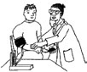

We are offering health check appointments at your surgery.

The date of your appointment is
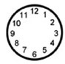
The time of your appointment is
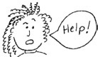
If this is not a good time or day, or you have any questions or worries about attending you can ring the surgery.
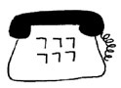
The surgery telephone number is
If you cannot make an appointment, you should let the surgery know at least a day before the appointment.

