Sample 1 Invitation for an annual health check and health action plan
Dear: ………………………………………………………………….
We have made you an appointment with your GP practice for a health check on: Date: ………………………………………………
Time: ………………………………………………………………….
If you can’t make this appointment, please let the surgery know as soon as you can.

Please Bring your Health Passport to the appointment if you have one
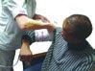
The health check is important to make sure that you are healthy and that you are getting the right help.
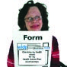
Please fill out the pre-health check form attached to this letter and bring it to the appointment. If you need help with this ring us. The surgery telephone number is: ………………………….
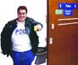
Please make sure that you bring a urine sample to the appointment.

At the appointment, you will also be asked if you want to have your own health action plan. If you have a Health Passport, we can add it to that.
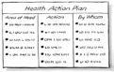
A health action plan will help you to look at ways to stay healthy. If you are not feeling well, it will help you getting the right support.

